Comoros

## Population Data

The data set shows the political stability estimate of the country each year.

## # A tibble: 23 x 5  
## country iso3c date population popCategory5  
## <chr> <chr> <dbl> <dbl> <chr>   
## 1 Comoros COM 1996 488627 very small   
## 2 Comoros COM 1997 501953 very small   
## 3 Comoros COM 1998 515385 very small   
## 4 Comoros COM 1999 528848 very small   
## 5 Comoros COM 2000 542357 very small   
## 6 Comoros COM 2001 555888 very small   
## 7 Comoros COM 2002 569479 very small   
## 8 Comoros COM 2003 583211 very small   
## 9 Comoros COM 2004 597228 very small   
## 10 Comoros COM 2005 611627 very small   
## 11 Comoros COM 2006 626425 very small   
## 12 Comoros COM 2007 641620 very small   
## 13 Comoros COM 2008 657229 very small   
## 14 Comoros COM 2009 673252 very small   
## 15 Comoros COM 2010 689692 very small   
## 16 Comoros COM 2011 706569 very small   
## 17 Comoros COM 2012 723871 very small   
## 18 Comoros COM 2013 741505 very small   
## 19 Comoros COM 2014 759390 very small   
## 20 Comoros COM 2015 777424 very small   
## 21 Comoros COM 2016 795592 very small   
## 22 Comoros COM 2017 813892 very small   
## 23 Comoros COM 2018 832322 very small

# Population growth data

## # A tibble: 23 x 5  
## country iso3c date popGrowth popGrowthCat5   
## <chr> <chr> <dbl> <dbl> <chr>   
## 1 Comoros COM 1996 2.75 high growth rate   
## 2 Comoros COM 1997 2.69 high growth rate   
## 3 Comoros COM 1998 2.64 high growth rate   
## 4 Comoros COM 1999 2.58 high growth rate   
## 5 Comoros COM 2000 2.52 high growth rate   
## 6 Comoros COM 2001 2.46 moderate growth rate  
## 7 Comoros COM 2002 2.42 moderate growth rate  
## 8 Comoros COM 2003 2.38 moderate growth rate  
## 9 Comoros COM 2004 2.37 moderate growth rate  
## 10 Comoros COM 2005 2.38 moderate growth rate  
## 11 Comoros COM 2006 2.39 moderate growth rate  
## 12 Comoros COM 2007 2.40 moderate growth rate  
## 13 Comoros COM 2008 2.40 moderate growth rate  
## 14 Comoros COM 2009 2.41 moderate growth rate  
## 15 Comoros COM 2010 2.41 moderate growth rate  
## 16 Comoros COM 2011 2.42 moderate growth rate  
## 17 Comoros COM 2012 2.42 moderate growth rate  
## 18 Comoros COM 2013 2.41 moderate growth rate  
## 19 Comoros COM 2014 2.38 moderate growth rate  
## 20 Comoros COM 2015 2.35 moderate growth rate  
## 21 Comoros COM 2016 2.31 moderate growth rate  
## 22 Comoros COM 2017 2.27 moderate growth rate  
## 23 Comoros COM 2018 2.24 moderate growth rate

## Population trend

The plot shows the population trend of the country.

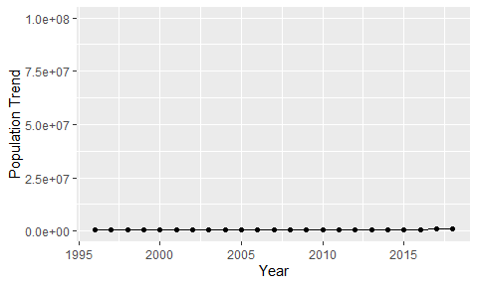

Political Stability Trend

# Population growth trend

The plot shows the population growth rate trend of the country.

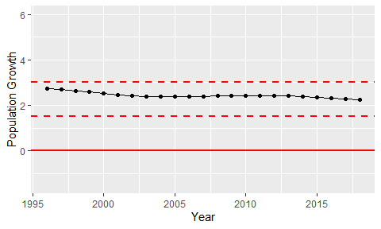

Population Growth Trend